Assignment 2

Problem Statement:

“The goal of this assignment is to create Hybrid Images using a modification of the approach described in the SIGGRAPH 2006 [paper](http://cvcl.mit.edu/publications/OlivaTorralb_Hybrid_Siggraph06.pdf) by Oliva, Torralba, and Schyns”

Software Used:

MATLAB R2018b

Solution:

Hybrid images are produced by adding the low frequency parts of one image to the high frequency parts of another. The image is perceived differently depending on the distance from which it is viewed. This implementation builds on the basic method specified in the paper authored by Oliva, Torralba and Schyns. It has three main parts: obtaining the low spatial frequencies of the first image, obtaining the high spatial frequencies of the second image and combining the images to create the hybrid image.

Before we begin, we must pre-process the images so that the future filtering steps run smoothly.

1. The images must be of the same size
2. The image array must be type cast into double datatype
3. The images are then converted into grayscale

Now that the images are formatted properly, we proceed in three phases:

1. Obtaining the low spatial frequencies of the first image

We begin by applying a Fourier Transform to the image using **fft2()**. This takes the image from the spatial domain into the frequency domain. Next, we create a Gaussian filter using **fspecial()**.This filter is then multiplied with the transformed image to cut off spatial frequencies higher than a set threshold (low passing). We then apply an inverse Fourier Transform using **ifft2()** to obtain the final low-passed image.

1. Obtaining the high spatial frequencies of the second image

The process of obtaining the high frequencies of an image is identical to the process of obtaining the low frequencies of the image aside from an additional last step in the case of the former. The second image is low passed in the same way as the first image but this time this low passed image is subtracted from the original image to leave only the high spatial frequencies. Additionally, the Gaussian filter is tweaked in such a way to not have much overlap between the frequencies of the two images.

1. Creation of the Hybrid Image

The images are then combined to form a hybrid image. The two images are added, pixel by pixel to create the final image.

Algorithm

1) Obtaining the Low Passed Image

1. Store the image ‘img1’
2. Convert the image to double datatype and then grayscale them
3. Transform the image from the spatial domain to the frequency domain by applying a Fourier Transform on it
4. Create a Gaussian filter
5. Multiply the transformed image with the Gaussian filter
6. Transform is product back into the spatial domain by applying an Inverse Fourier Transform. This gives us the Low Passed Image

2) Obtaining the High Passed Image

1. Store the image ‘img2’
2. Convert the image to double datatype and then grayscale them
3. Transform the image from the spatial domain to the frequency domain by applying a Fourier Transform on it
4. Create a Gaussian filter, such that the frequencies of the two images do not overlap much
5. Multiply the transformed image with the Gaussian filter
6. Transform is product back into the spatial domain by applying an Inverse Fourier Transform
7. Subtract the re-transformed image from the original image ‘img2’ to obtain the High Passed Image

3) Creating the Hybrid Image

1. Combine the low passed image and the high passed images by adding the gray values of corresponding pixels
2. Display Hybrid Image

Results

The following results were obtained using for different pairs of images.

Set 1:

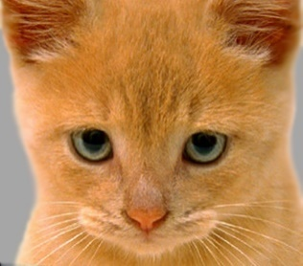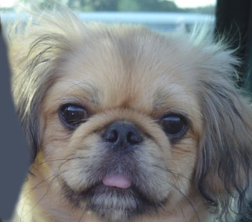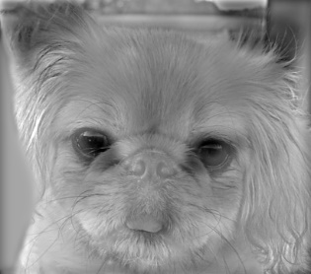

Set 2:

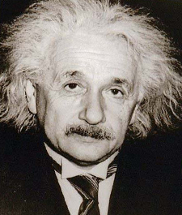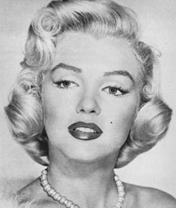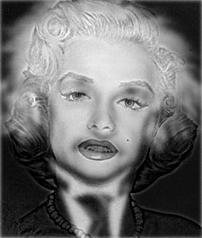

Set 3:

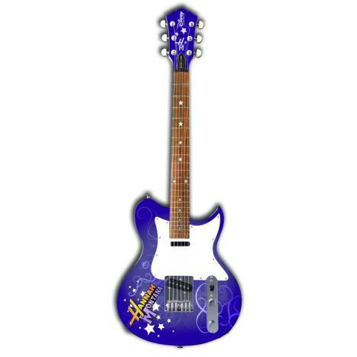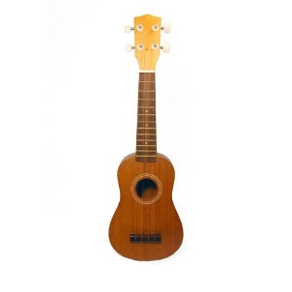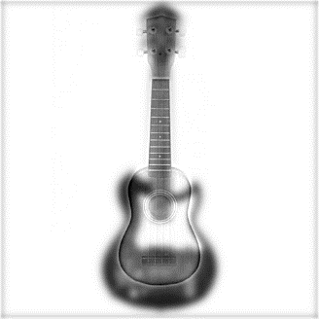

Set 4:

